

V2.1

Add School or Function Name this line

nearest defibrillator location VIA QR-code | 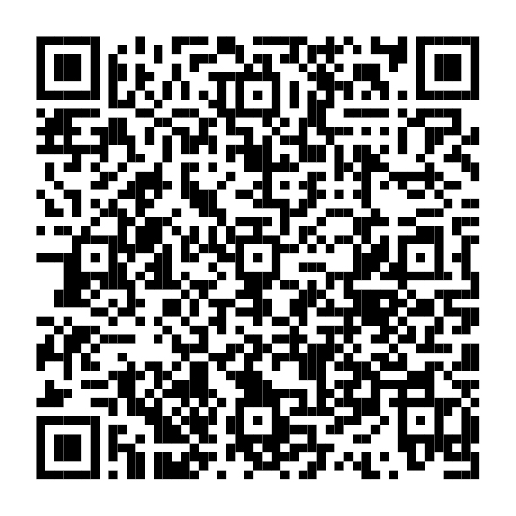

FIRST AID BOX LOCATIONS

QUALIFIED FIRST AIDERS
Name | Usual location | Telephone Ex. No. | Certification End Date

APPOINTED PERSONS [delete section if n/a]
(non-treatment assistance )
Name | Usual location | Telephone Ex. No.

First Aiders Available
- 09:00 – 17:00 (as above)
- At other times – SECURITY CONTROL – Extension 6300 (0118 378 6300)
- For an ambulance, dial 0-999 for Emergency Services.
State location: XXXXX Building, via XXX entrance, XXXX campus [Edit red]
- Then dial Security Control ext. 6300, to advise that an ambulance has been called.

Please report all accidents, however minor, using the University online reporting system via the Q-R code. Thank you, H&S Services. | 