How to set up a Researchfish Account
This user guide will guide you through the process to sign up for a Researchfish account to allow you to submit outcomes for your grants.

- Invite
You can only create an account if you have received an e-mail invite. If you are a Principal Investigator (PI) this will originate from your research funder. If you a collaborator on a project the invite will be sent from your PI.
All invites will look similar to the one shown below
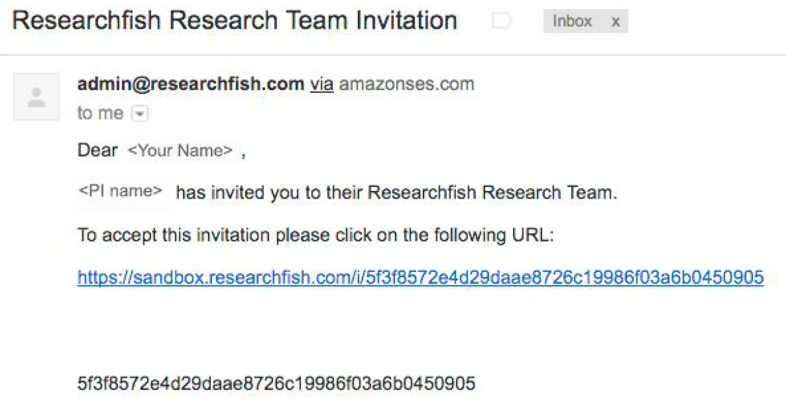
If you have not received an invite please go to https://app.researchfish.com/helpwiz and select Invitation Help. You will then be asked to input your research funder, your first initial and your surname.

- Accept Invitation
Click on the link provided in the e-mail invitation to proceed to the Researchfish website.
The following screen will be presented:

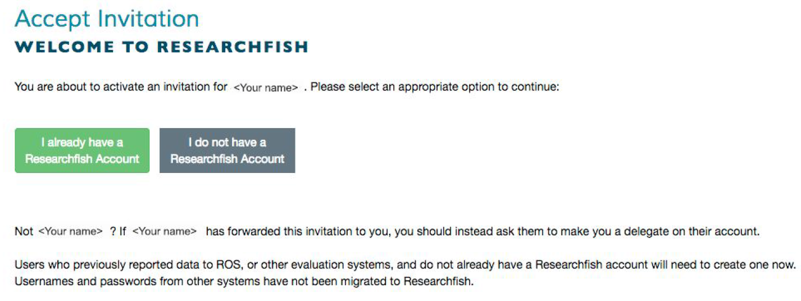
If you have previously set up an account but have forgotten your username and/or password click on I already have a Researchfish Account to allow you to reset them.
If you are setting an account up for the first time click on I do not have a Researchfish Account which will take you to the account creation page.

- Create an Account
The following account creation form will then be displayed.

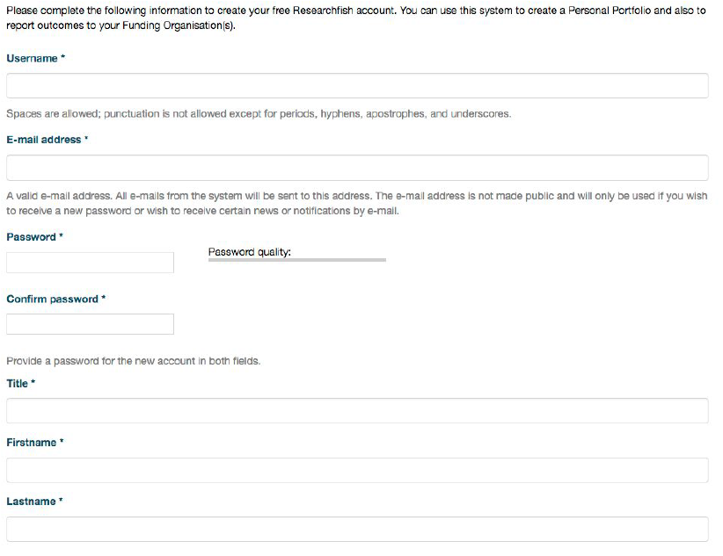
Complete the form as specified and click on Create an Account to complete the registration process.
On registration you will then be taken to the main My Awards page. All awards for which you are a Principal Investigator and are required to submit outcomes will be displayed on this page. Additionally any awards on which you are a collaborator will also be displayed on this page.

